Give a suitable title of your manuscript

Don’t include author name in manuscript submission.

Abstract
Explain your work in few lines. Keep the word limit within 250 to 300. For further instructions click here and watch this YouTube video and prepare accordingly. https://www.youtube.com/watch?v=_KjUYIk2Dnk

Keys: use; some; descriptive; words; separated; by; semicolons; limited; to; max.; five;, keys.

1 Introduction
Introduce the content of this paper in brief. Maintain the indentation and the exact template till the last dot of this manuscript. Without this manuscript may be returned without any notice.

2 Background
Describe the paper background if applicable.

3 Section III

Here is the use of the subsections. Use this bulletins for inclusion of the subsections.

First section
Description of the first section.

Next section
Describe this section here. Continue the section as per requirement.

Section
Describe this section here.
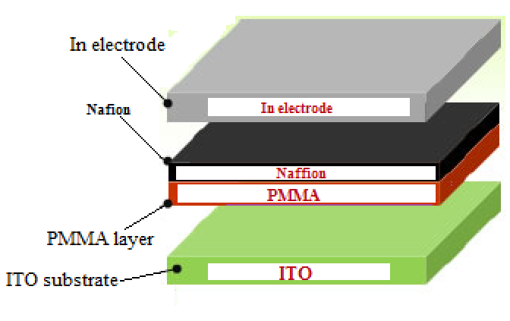

Figure 2 |Caption of the image.

- Conclusion

Conclude with the suitable conclusion paragraph.

Acknowledgement
Use this section is applicable.

References [Use the suitable style as per given]
- Fushan Li, et.al. , "Nonvolatile Memory Effects of ZnO Nanoparticles Embedded in an Amorphous Carbon Layer", Japanese Journal of Applied Physics 49 (2010) 070209.
- Biswanath Mukherjee and Moumita Mukherjee, "Nonvolatile memory device based on Ag nanoparticle: Characteristics improvement" Applied Physics Letters 94, 173510 (2009); doi: 10.1063/1.3127233.
- V. L. Covin, M. C. Schlamp, and A. P. Alivisatos: Nature (London) 370 (1994) 354.
- T. Homma, T. Kutsuzawa, K. Kunimune, and Y. Murao: Thin Solid Films 235 (1993) 80.
- M. Horie: J. Vac. Sci. Technol. A 3 (1995) 2490.
- S. Mizuno, A. Verma, H. Tran, P. Lee, and B. Nguyen: Thin Solid Films 283 (1996) 30.
- H. J. Ko, K. M. Lee, H. J. Lee, and C. K. Choi: Thin Solid Films 506–507 (2006) 8 .
- Z. J. Donhauser, B. A. Mantooth, K. F. Kelly, L. A. Bumm, J. D. Monnell, J. J. Stapleton, Jr., D. W. Price, A. M. Rawlett, D. L. Allara, J. M. Tour, and P. S. Weiss, Science 292, 2303 2001 .

